**Lab 02:**

**Configuring MASM with textpad editor &**

**AL Arithmetic Instructions**

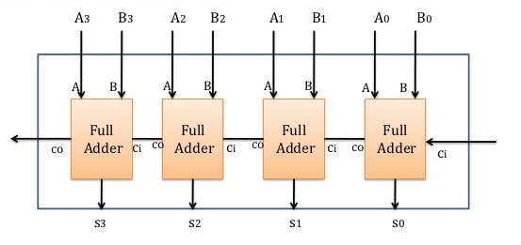

**Lab 02:**

**Pre-lab:**

**Software required:**

* **MASM 6.15 (Assembler)**
* **32-bit operating systems**
* **Text pad editor(32-bit)**
* **Source code**
  + **Irvine book resource (shared on group)**

**Goal:**

The purpose of lab 02 is to assemble programs containing basic arithmetic instructions using window’s text pad editor.

**Target of Lab 02:**

1. Part 01: Configuring MASM 6.15 with text pad editor.
2. Part 02: Understanding & assembling basic arithmetic instructions in AL programs**.**

**Procedure:**

Lab is divided into two parts, first part is as under

**Part I: Configuring MASM 6.15 with text pad editor.**

**Build 32-bit MASM**

Install text pad editor (available on group) on your system and open it, See the figure below.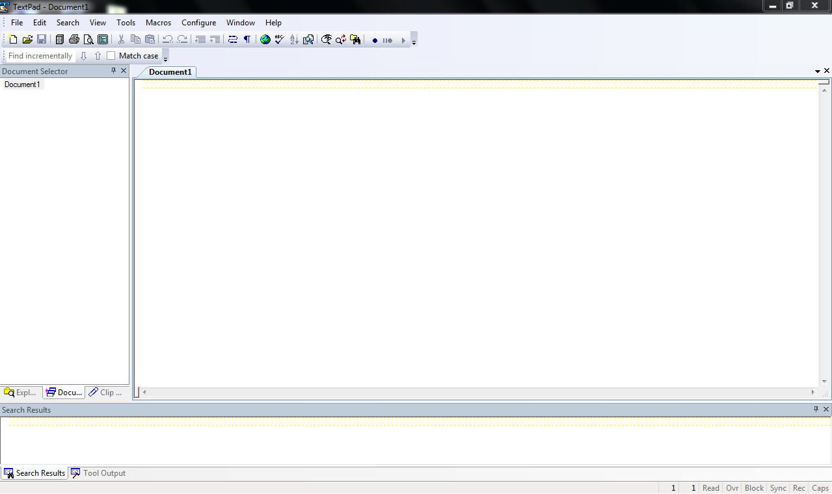

Go to configure menu & select *Preferences.*

* Select *Tools* in the left hand pane, click on the *Add* button (as shown in figure below) and select *"DOS command ..."* from the drop-down list.

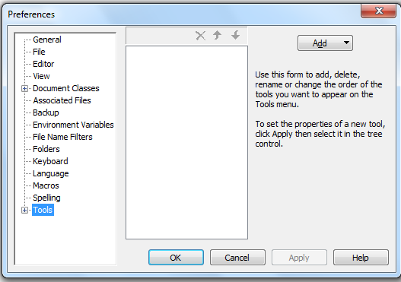

* When the popup dialog appears, enter the following and click OK as shown in figure below.

**C:\Masm615\make32.bat $BaseName**

***Note: It assumes you have already installed Masm in directory.i.e. C:\Masm615***

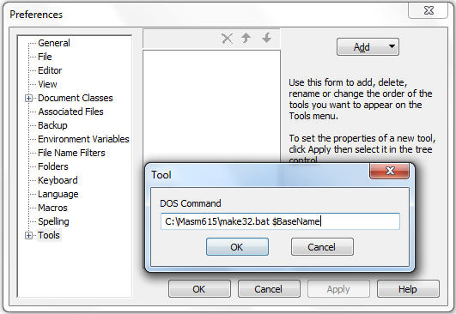

* Click the Apply button.

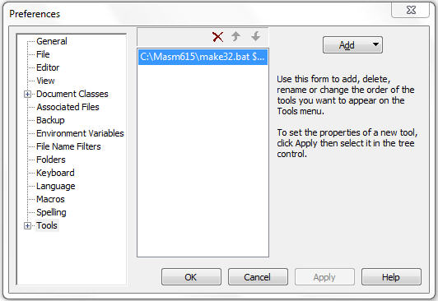

* Next, you will rename the above command to **Build 32-bit MASM**. To do this, click once on the name, wait a second, and click again. When it turns blue, retype the command's name and press Enter.

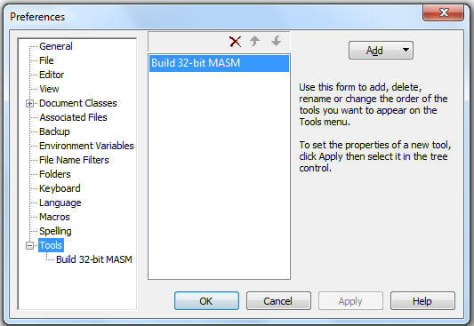

* Click Apply to save the setting.
* Select the Tools menu on left hand pane, and click on ***Build 32-bit MASM*** command. In the right-hand pane, clear the Capture output options. Following is a sample screen snapshot.

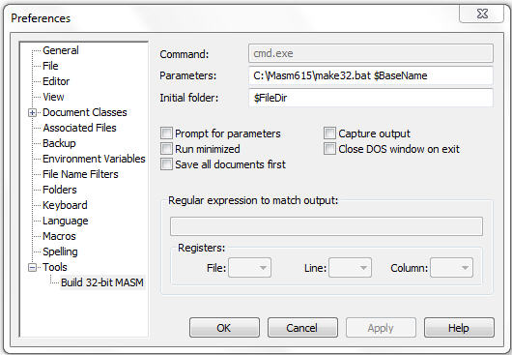

* Click OK to save your changes and quit.

**Run ASM Prog**

* Similar steps apply here, Go to configure menu & select Preferences.
* Select Tools in the left hand pane, click on the Add button (as shown in figure below) and select "DOS command ..." from the drop-down list and type the following command.

**$BaseName**

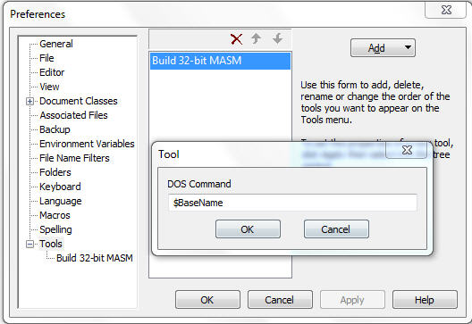

* Click the ok and Apply button.

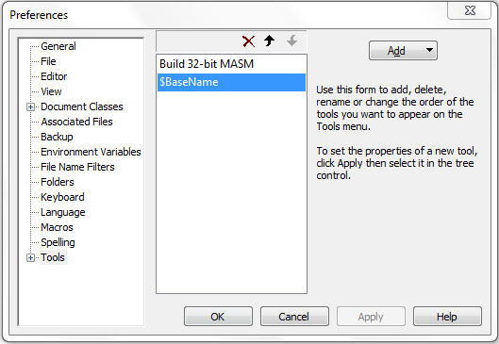

* Next, rename the above command to **Run ASM Prog**. To do this, click once on the name, wait a second, and click again. When it turns blue, type the command's name and press Enter. Click Apply.

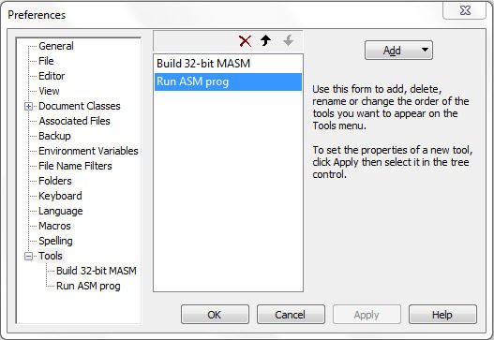

* Click on the "+" next to Tools in the left-hand pane. When the list expands, select Run ASM Prog. In the right hand pane of the dialog, remove the check mark next to Capture output.

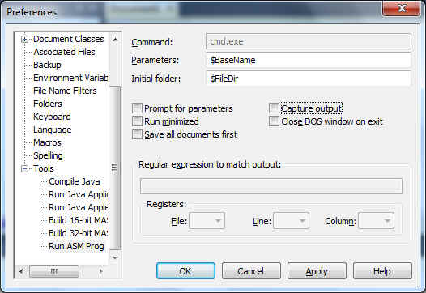

* Click OK to close the dialog and save your changes.

*Pat gently on your back,MASM configured with windows editor and part1 of lab completed.* **☺**

**Part II: Assembling AL programs: Arithmetic(MOV,ADD,SUB) Instructions**

**Run AL Program in MASM**

* Start your Text Pad program, unzip the Irvine lab resources to C: root directory. Browse this directory and open AddSub.asm program from **codesCh03** folder. **C:\codesCh03**

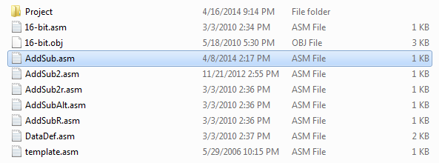

* Select *AddSub.asm* file and open it as shown in figure.

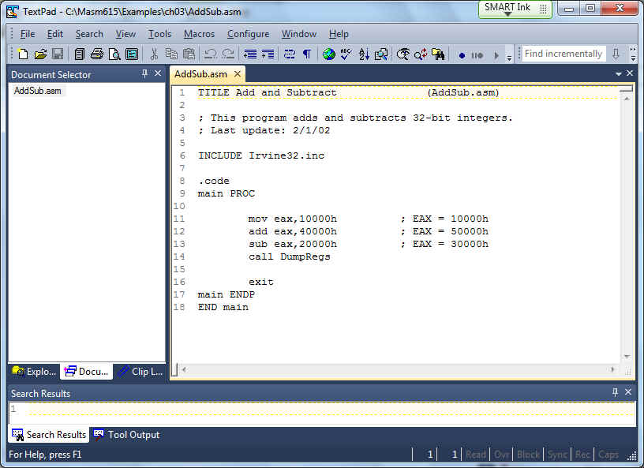

* **Assembling the Program:**Hold and press Ctrl+5, or Click on *Tools,*and then*External Tools*, and then select *Build 32-bit MASM.*The popup console appears, as follows. Press any key to kill the console.

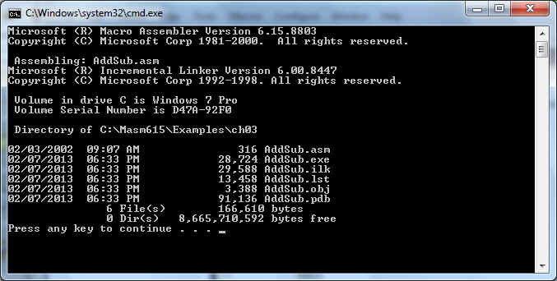

* **Run the Prog:**Hold and press Ctrl+6, or Click on *Tools,*and then*External Tools*, and then select *Run ASM Prog.*The popup console appears, as follows. Press any key to kill the console.

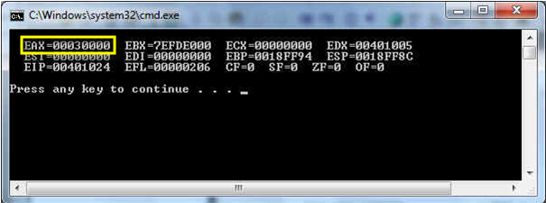

**Finally lab ended …..Take rest, you deserve it after this lengthy lab ☺**

**Post LAB:**

It’s your turn to open, assemble and execute all other AL programs available in lab 03 resource provided to you on group. Observe given program syntax and analyze how particular output is being generated by correlating with source code.

**Notes / Comments:**